**Amrita School of Engineering, Amritapuri Campus.**

**19CSE213: Operating Systems**

**LAB SHEET 2**

**Patel Rajkumar Pankajbhai AM.EN.U4CSE20349**

Linux:-Filters, Regular Expressions and Shell Programming

Lab Exercise

1. Create a file **demo** with the following contents

Student Alice Essentials 20 PSAT 22 Maths 34 Cultural 25 English 70

Student Bob Essentials 23 PSAT 21 Maths 32 Cultural 18 English 94

Student Boby Essentials 43 PSAT 31 Maths 22 Cultural 8 English 93

Student Clara Essentials 18 PSAT 16 Maths 27 Cultural 12 English 45

Student Dirck Essentials 25 PSAT 23 Maths 48 Cultural 25 English 98

Student Eve Essentials 8 PSAT 6 Maths 12 Cultural 13 English 5

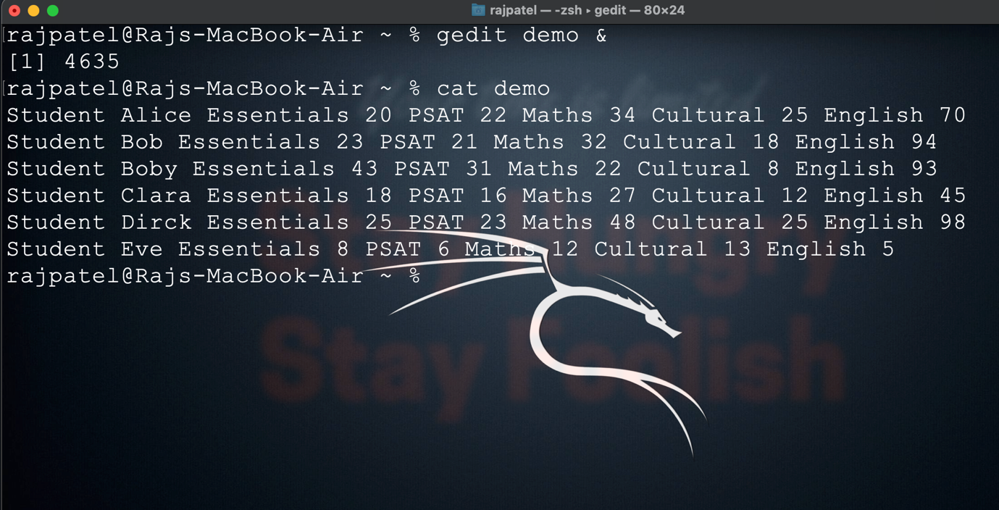

1. Find the marks obtained by Clara in all the subjects

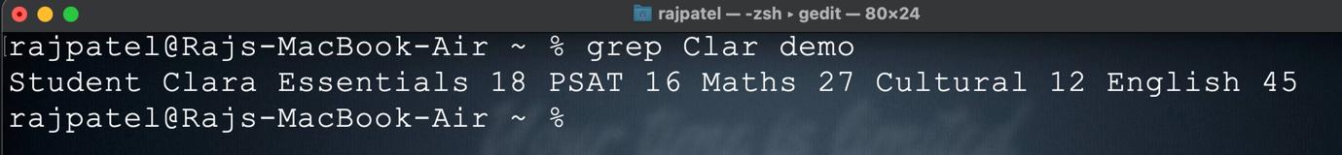

1. Print the marks for essentials in the increasing order

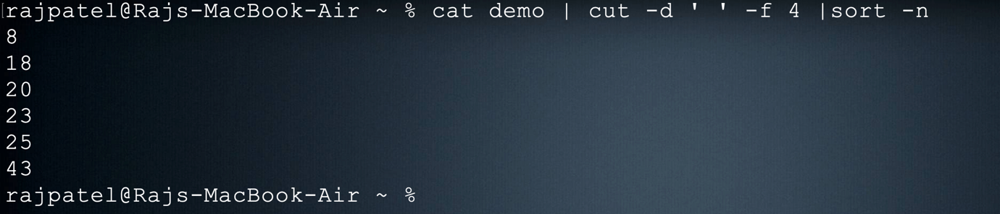

1. Find the maximum marks scored in PSAT

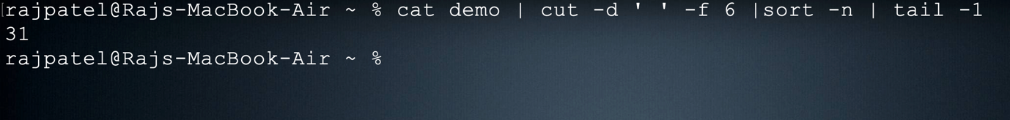

1. Find the minimum marks obtained in Cultural

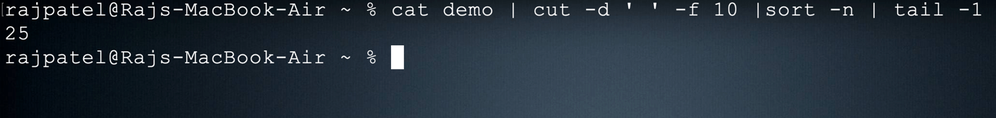

1. Save the marks obtained by all the students in maths into a file and display it in the terminal using a single command

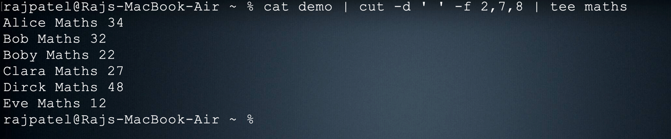

1. Print the first 3 letters of all student names.

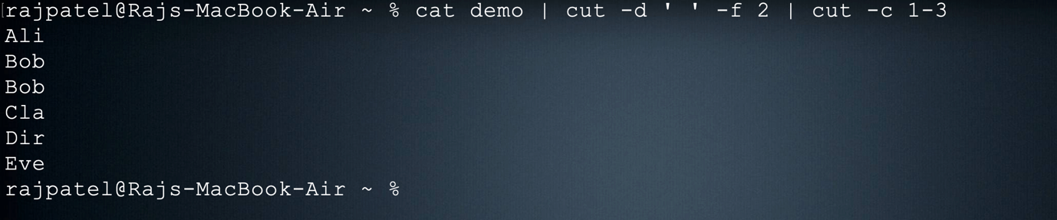

1. Print the contents of file **demo** in terminal with all alphabets in capital letters.

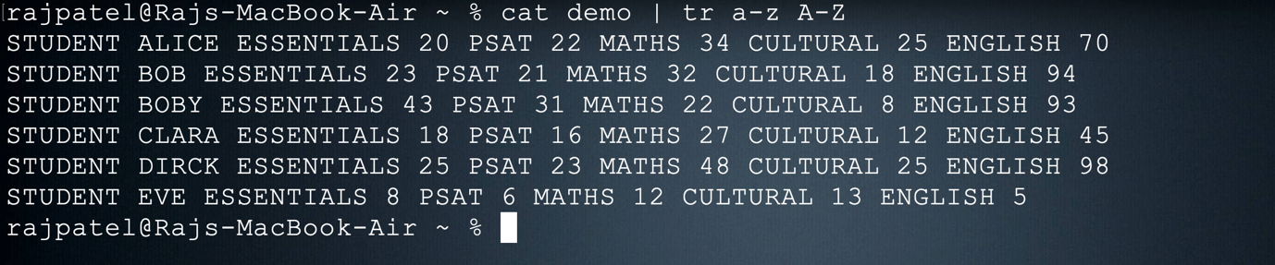

1. Print all student names after deleting the letter ‘a’

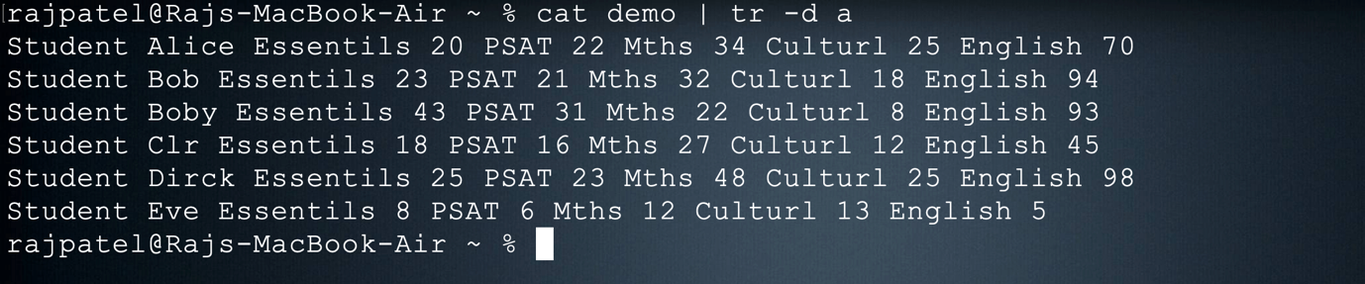

1. Count the number of lines, words and characters in demo file after removing the letter ‘S’

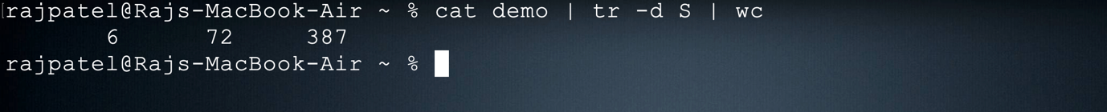

1. Find the number of students with their names containing the letter a, e or i

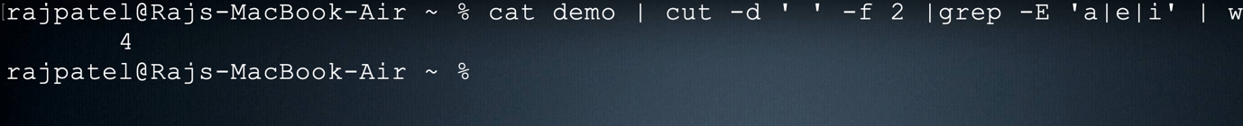

1. Find the marks of students whose names starts with ‘b’ (case insensitive)

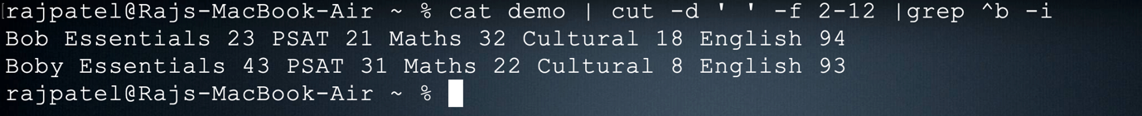

1. Find the names of students whose names starts with ‘b’ and ends with ‘y’ (case insensitive)

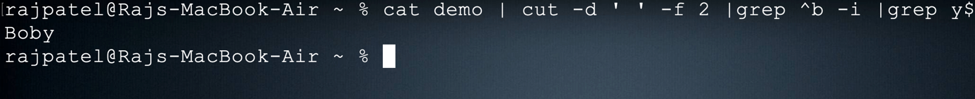

Shell Programming

1. Write a shell program to perform the following actions in the given order.
   1. Create a directory hierarchy in your home folder



* 1. Create a file file1 in directory Test3 with the contents same as output of the command ls -l
  2. Go to directory Test3
  3. Find the names of all files and folders in file1
  4. Find the names of all files and folders starting with d(case insensitive)
  5. Print all words of file1 on a separate line.
  6. Go back to your home directory.

Script :

#!/bin/bash

echo " "

echo "Creating the directories Test1->Test2->Test3"

echo " "

mkdir -p Test1/Test2/Test3

echo "Directories created successfully"

echo " "

echo "Creating file1 at Test1/Test2/Test3"

echo " "

touch Test1/Test2/Test3/file1

echo "File1 created successsfully"

echo " "

echo "Storing the content of 'ls' command in file1 "

echo " "

ls > Test1/Test2/Test3/file1

echo "Content saved successfully to file1"

echo " "

echo "Changing Directory to Test3"

cd Test1/Test2/Test3

echo " "

echo "Files and folder starting with 'd' are "

echo " "

cat file1 | grep ^d -i

echo " "

echo "Displaying the content of file1 in new lines"

echo " "

cat file1 | tr ' ' '\n'

echo " "

echo "Script excuted Successfully"

echo " "

cd ~

echo "returning to root directory"

Output

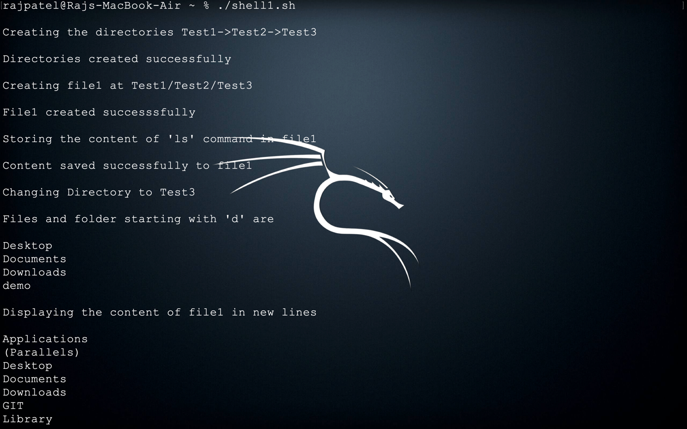



1. Write a shell program to perform the following actions in the given order.
   1. Create a file **numericdata** with the following contents

Karunagappally 34567 7864 6785

Kollam 56754 6754 7654

Vallikkavu 54328 7548 45675

Trivandrum 16423 6654 6754

Ernakulam 28796 8549 9875

Kayamkulam 35589 75892 3451

kottayam 45557 6773 6547

tirukulum 45675 56476 7896

(Hint : First field is referred as Place second as code1 third as code2 and fourth as code3)

* 1. Display the details of Places that starts with ‘T’(case sensitive)
  2. Display code3 in sorted order(ascending) of the places that start with ‘K’(case insensitive)
  3. Filter code2 that starts with 6 and ends with 4
  4. Filter code2 having one or more occurrence of the digit 6.
  5. Filter all code1 having one or more occurrence of the digit 5.

Script

#!/bin/bash

echo " "

echo "Creating file name 'numericdata'"

touch numericdata

echo " "

echo " file created successfully "

echo " "

echo " Saving the content to the file 'numericdata' "

echo " "

echo "Karunagappally 34567 7864 6785" > numericdata

echo "Kollam 56754 6754 7654" >> numericdata

echo "Vallikkavu 54328 7548 45675" >> numericdata

echo "Trivandrum 16423 6654 6754" >> numericdata

echo "Ernakulam 28796 8549 9875" >> numericdata

echo "Kayamkulam 35589 75892 3451" >> numericdata

echo "kottayam 45557 6773 6547" >> numericdata

echo "tirukulum 45675 56476 7896" >> numericdata

echo "Content Saved successfully"

echo " "

echo "Displaying details of place stating with 't' "

echo " "

cat numericdata | grep ^T

echo " "

echo "Displaying code3 insorted order of the places that start with 'k' "

echo " "

echo "Code-3"

cat numericdata | cut -d ' ' -f 1,4 | grep ^K -i |cut -d ' ' -f 2 | sort -n

echo " "

echo "Displaying code2 that starts with 6 and ends with 4"

echo " "

echo "Code-2"

cat numericdata | cut -d ' ' -f 3 | grep ^6 | grep 4$

echo " "

echo "Displaying code2 having one or more occurrence of the digit 6"

cat numericdata | cut -d ' ' -f 3 | grep -E '6+'

echo " "

echo "Displaying code1 having one or more occurrence of the digit 5."

echo " "

echo "Code-1"

cat numericdata | cut -d ' ' -f 2 | grep -E '5+'

echo " "

echo "Script executed Successfully "

echo " returning to root directory "

cd ~

Output

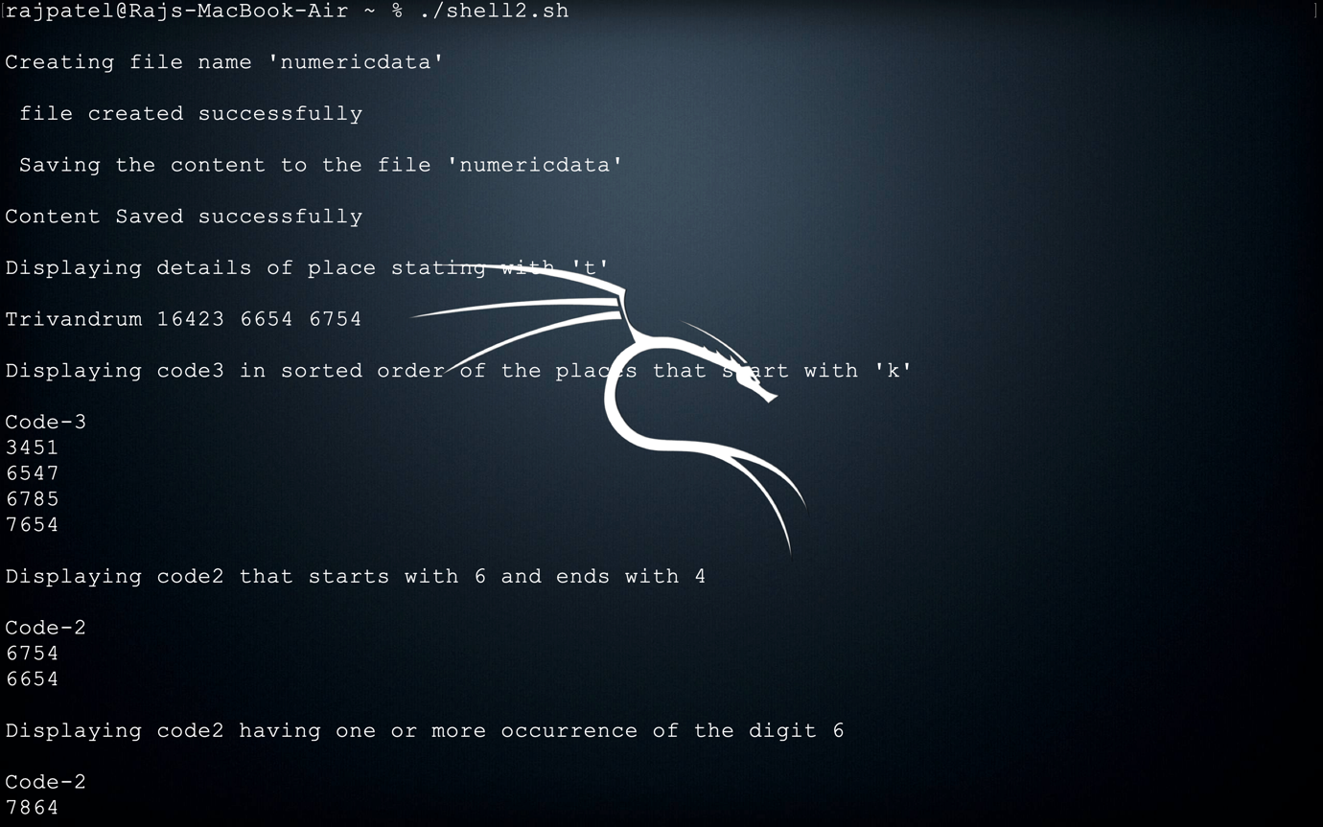

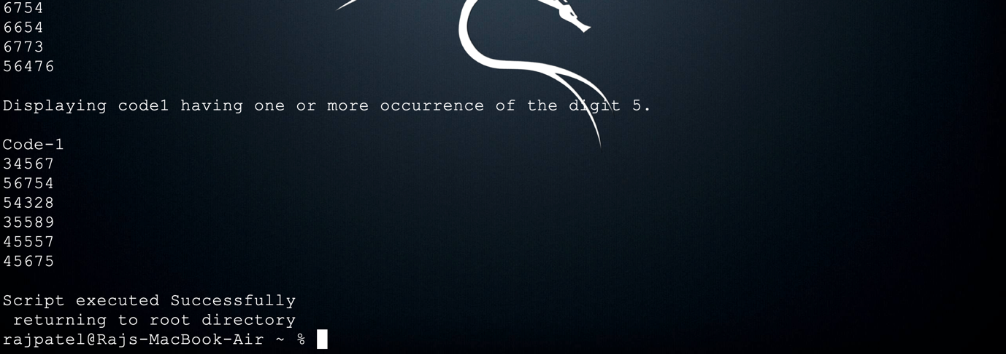

=========== The End ===========